How can I register for the APMLE Part I, APMLE Part II (Written) or APMLE Part III?
You may register online by Creating Your Online Account at https://assessments.meazurelearning.com/Connect/APMLE/Account/Login and select “First Time User”. Complete all the required fields and click “Create Account”. You will then receive an Account Activation email. YOU MUST CLICK ON THE LINK IN THE EMAIL WITHIN 24 HOURS OF RECEIPT or you will have to recreate your account. This will validate your email address. You can then go to https://assessments.meazurelearning.com/Connect/APMLE/Account/Login and enter your username and password to log in. You will only be able to apply for the exam which you are eligible for. Once your application is approved, you will receive a notification email that your application is approved and ready for you to submit payment. For further details and instructions, please see the APMLE Candidate Bulletin.
Note: If you are accessing the online system for the first time, click “First Time User” to set up your username and password.
If you previously registered using the online process, please log in using your existing username and password. You will not need to create a new account.

May I request a location other than the testing site near my school to sit for the Part I/II Written Exam?
Yes. When scheduling for your exam you will be able to see all available test site locations. If you do not see a test site location within a 50 mile radius DO NOT SCHEDULE. Please contact Candidate Support at candidatesupport@meazurelearning.com or call at 919-572-6880 for assistance in locating a site that may be closer. A representative will check if a seat is available.
How do I transfer to a new administration date?
To transfer to a new administration date, a candidate must cancel any scheduled appointment by paying a $50 rescheduling/cancellation fee within the scheduling system through their original NTS before the below deadlines.
- Testing on Monday – End of the day Saturday
- Testing on Tuesday – End of day Sunday
- Testing on Wednesday – End of the day Monday
- Testing on Thursday – End of the day Tuesday
- Testing on Friday – End of the day Wednesday
- Testing on Saturday – End of the day Thursday
- Testing on Sunday – End of the day Friday

There is no deadline for candidates who have yet to schedule their examination. The deadline for transferring to another window for candidates with a scheduled appointment is two (2) days before the originally scheduled exam date.
Candidate must submit a request in writing to candidatesupport@meazurelearning.com. A new Notice to Schedule will be sent to the email on file, where the candidate must pay the $100 transfer fee at the time of scheduling.
Candidates can transfer as many times as they would like by paying the $100.00 transfer fee each time and submitting a written request to Candidate Support, as long as they have canceled any scheduled exam dates at least two (2) days in advance of the originally scheduled exam date by paying the rescheduling fee of $50.00.
How do I submit an ADA request?
Candidates can submit an ADA request through the application process in the Connect application system. If an ADA accommodation was previously approved by your school, no additional documentation will be required. ADA requests will be reviewed and approved by the dean of your school. If you have an ADA request that is not standard (example of standard requests are additional time or a private room), you may be asked to provide supporting documentation. You will receive an ADA Feedback email directly from the Connect application system, requesting that you contact candidatesupport@meazurelearning.com so they can send you a document upload email containing a link to securely upload your documentation to be sent to the Dean for review.

What if I have additional questions?
If you read the Bulletin and have further questions about the registration process, fees, test centers, Notice to Schedule or how to access score reports, you may contact:
Meazure Learning Candidate Support
P.O. Box 570, Morrisville, NC 27560
Phone: (919) 572-6880
Email: candidatesupport@meazurelearning.com

Part I, II Written or III – Create Your Online Account Instructions

Below are steps that outline how to create your online account, apply for, and schedule your APMLE Part III examination.

Important:

Please use a valid PERSONAL email address when creating your account.

Payment for the examination fee must be made by credit card once the application is approved by dean and/or state board.

Step 1: Create your online account.

Create your online account (First-time Users)
- Visit https://assessments.meazurelearning.com/Connect/APMLE/Account/Login and then create your online account by selecting “First Time User.”
- Acknowledge that you have read and agree to the Meazure Learning Data Privacy Policy.
- Complete all required information:
- Username
- Email address
- Password
- Demographic Data
- Click on “Create Account”
- You will receive an Account Activation email.

- You must click on the link in the email within 24 hours. After 24 hours you must recreate your account.
- This will validate your email address.

- Visit https://assessments.meazurelearning.com/Connect/APMLE/Account/Login and then select “Sign In.”
- From the Login Page, enter your existing username and password.

OR

Log in to your account (Existing Users)
- Visit https://assessments.meazurelearning.com/Connect/APMLE/Account/Login and then select “Access My Account.”
- From the Login Page, enter your existing username and password.

Step 2: Apply for your exam.
- Log in with your Meazure Learning account to view your Dashboard. Click on “Create” next to the exam name under “ My Testing Activities” to complete your application.
- Once you have completed your application, click on “Submit.”
- Your application will then be submitted for approval.
- Once approved, you will receive a notification email that your application is approved and ready for you to submit payment.
- You will need to sign back into your online account and provide payment to complete the application.
- After the payment is processed, you will promptly receive a notification email outlining the necessary next steps to schedule your exam.

Step 3: Schedule your exam.
- Enter username and password from the Notice To Schedule (NTS) email and then click Login.

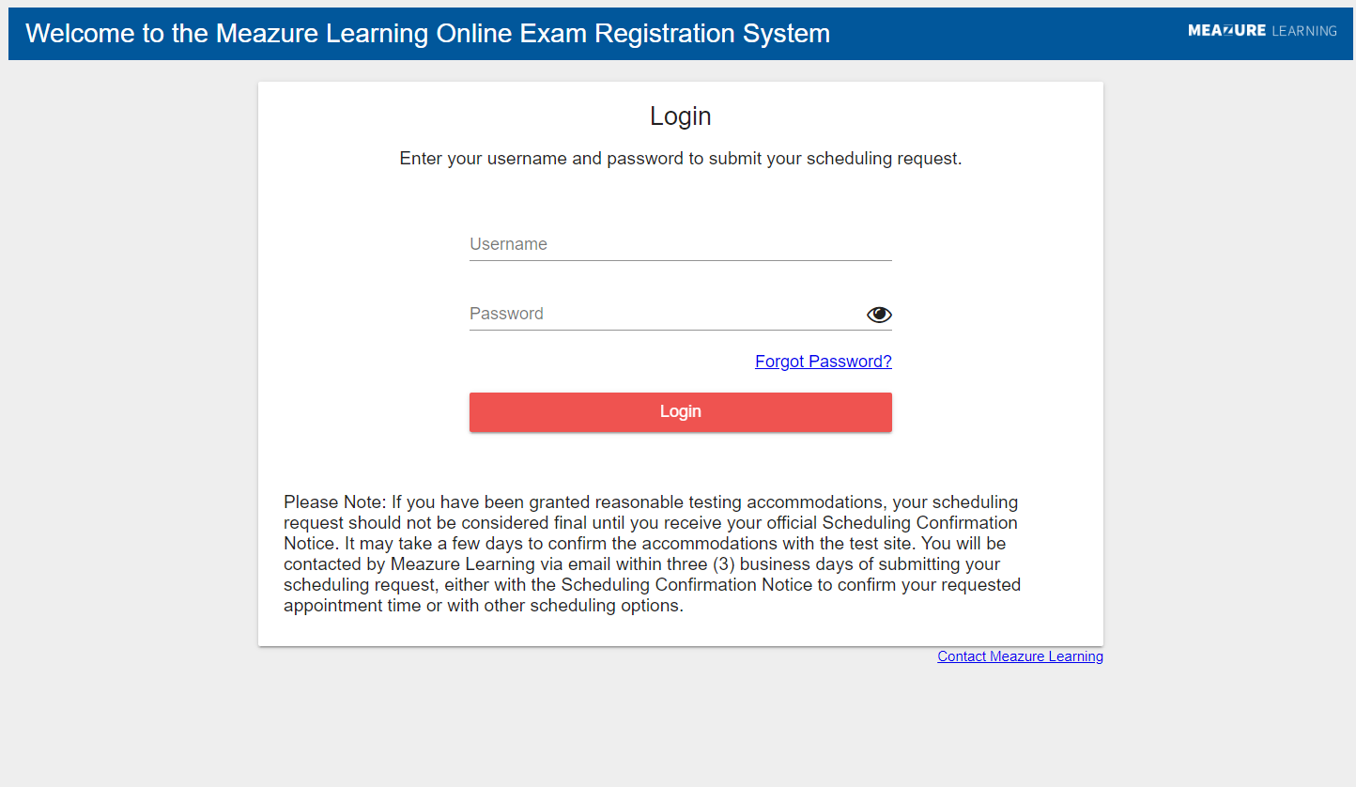
- Agree to Privacy Policy by reading to the bottom and then clicking Agree.

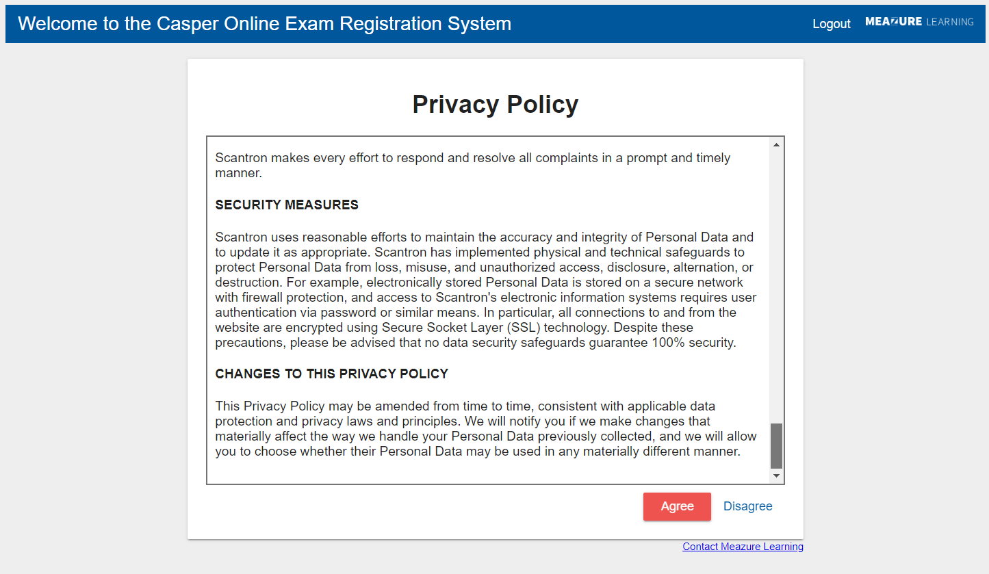
- Enter/Update demographic information and click Continue.

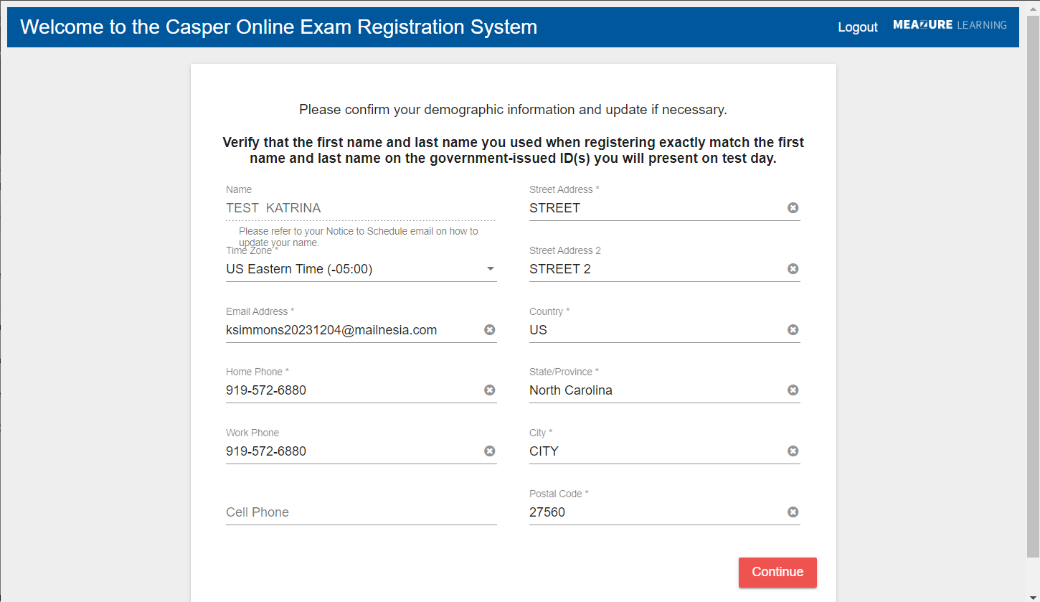
- Read the Examination Admission Requirements, check the box next to I attest, and click Continue. The screenshot is missing the top.

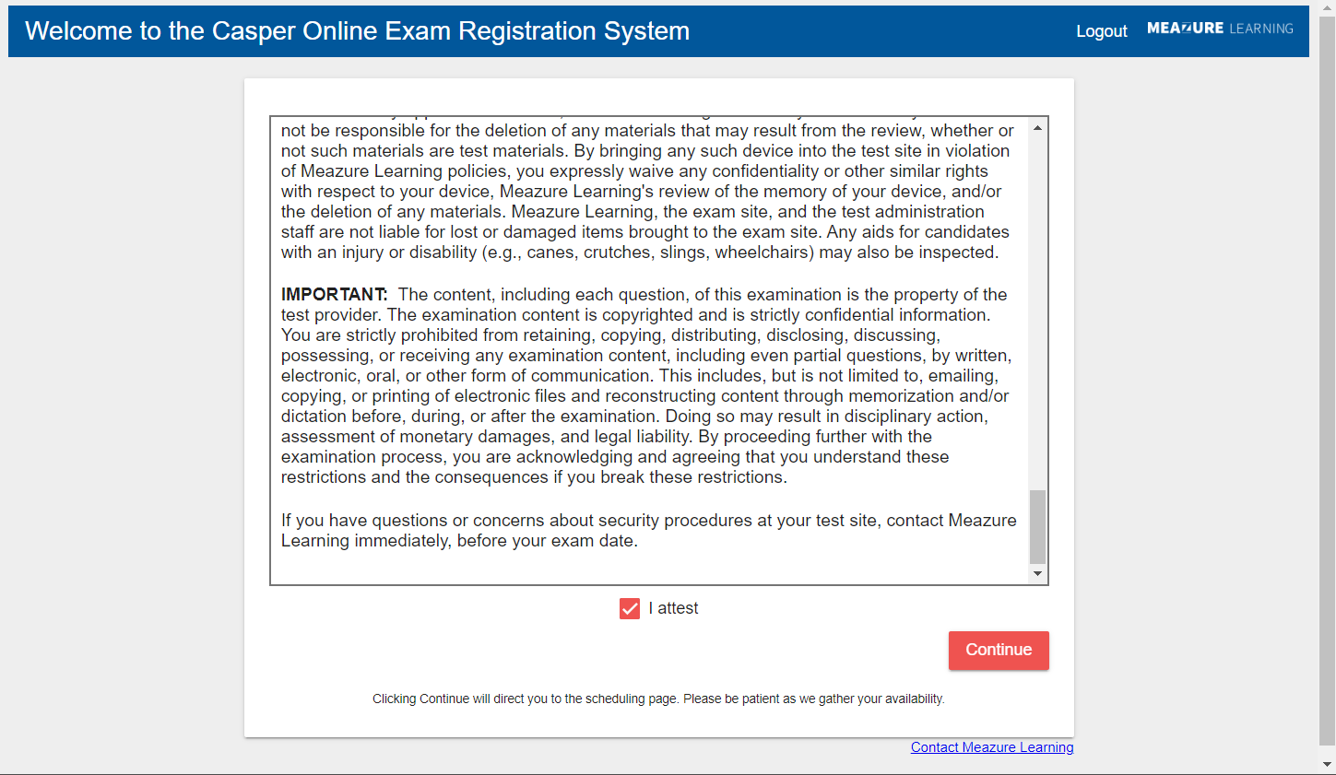
- Enter the date & location you wish to test and click Get Locations.

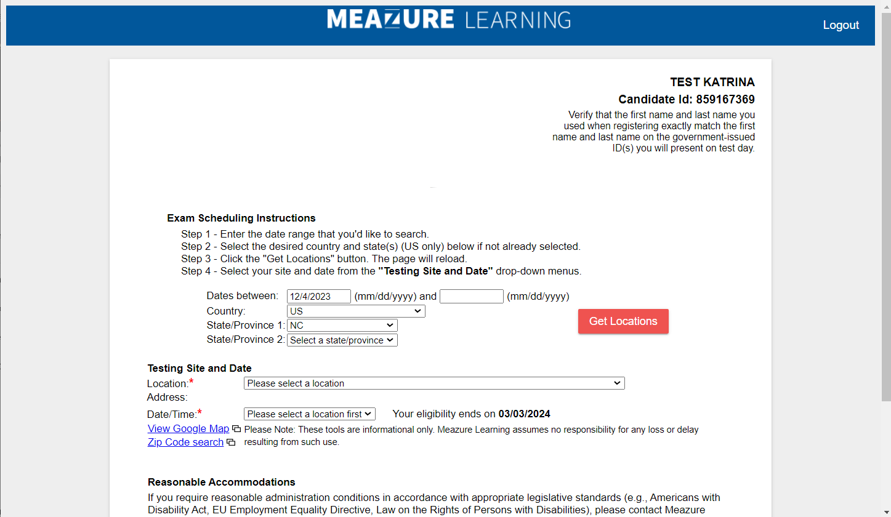

- Choose a test site and date/time and click Submit.

- A thank you page will appear when your registration request is submitted successfully.

